<SoLove Co.,Ltd.>

**<Work BreakdownStructure>**

**<Student Association Management Sytem>**

Version 1.0

Prepare by

Mr.Sitta Chumklaew 5730213074

Miss.Uraiwan Puakphet 5730213031

Miss.Puttinun Duangsamran 5730213038

Mr.Jasadaporn Sain-Un 5730213073

Mr.Tanawat Meechai 5730213080

Mr.Pasin Sommung 5730213096

21/10/2016

Table of Contents

1. Revision History……………………………………………………………………………………………………………………………….……1

2. Use Case Overview……………………………………………………………………………………………………………………………….1

Use Case Diagram Level 0: Inventory and Point of Sale Management System….….......................1

Use Case Diagram Level 1: Repair’s Management Sub-System (UC100)………………………………………2

Use Case Diagram Level 1: Device’s Management Sub-System (UC200)……………………………………..2

Use Case Diagram Level 1: Show Information Sub-System (UC300)……………………………………………..3

Use Case Diagram Level 1: Personal’s Management Sub-System (UC400)…………………………………..3

Use Case Diagram Level 1: Shop and Bill Sub-System (UC500) ……………………………………………………4

Use Case Diagram Level 1: Report Sub-System (UC600) ……………………………………………………………….4

Use Case Diagram Level 2: Customer Repairs Management (UC110) …………………………………………..5

Use Case Diagram Level 2: PhoneGeneration Management (UC210) …………………………………………….5

Use Case Diagram Level 2: Phone’s Generation Management (UC310) ………………………………………..6

Use Case Diagram Level 2: Personal’s Management (UC410) ………………………………………………………..6

Use Case Diagram Level 2: Bill Management (UC510) ……………………………………………………………………7

Use Case Diagram Level 2: Shop Management (UC520) …………………………………………………………………7

Use Case Diagram Level 2: Report (UC610).......................................................................8

3. System Structure…………………………………………………………………………………………………………………………..…….9

4. Static Structure and Data Analysis…………………………………………………………………………………………………10

4.1 Model View Controller (MVC) Model………………………………………………………………………………………..10

4.2 Entity Class Model…………………………………………………………………………………………………………………………..22

5. System Behaviour Model………………………………………………………………………………………………………………..23

Sequence Diagram demonstrating operation “ Add Repairs” ......................................................23

Sequence Diagram demonstrating operation “ Edit Repairs”......................................................23

Sequence Diagram demonstrating operation “ Delete Repairs”....................................................24

Sequence Diagram demonstrating operation “ Bill Repairs” ......................................................24

Sequence Diagram demonstrating operation “ Add new Phone’s Generation”................ ..............25

Sequence Diagram demonstrating operation “ Edit Phone’s Generation”…………………………………………….26

Sequence Diagram demonstrating operation “ Delete Phone’s Generation”...................................27

Sequence Diagram demonstrating operation “ Search Phone’s Generation”...................................28

Sequence Diagram demonstrating operation “ show customer take back”....................................29

Sequence Diagram demonstrating operation “ turn back to customer”.........................................30

Sequence Diagram demonstrating operation “ waiting for repair”………………………………………………………..31

Sequence Diagram demonstrating operation “ repair is done”………………………………………………………………32

Sequence Diagram demonstrating operation “ Take to repair canter”…………………………………………………33

Sequence Diagram demonstrating operation “ Add User”…………………………………………………………………….34

Sequence Diagram demonstrating operation “ Edit User”…………………………………………………………………….34

Sequence Diagram demonstrating operation “ Delete User”………………………………………………………………..35

Sequence Diagram demonstrating operation “ Bill Repairs”………………………………………………………………..35

Sequence Diagram demonstrating operation “ Add Bill”……………………………………………………………………..36

Sequence Diagram demonstrating operation “ Update Bill”…………………………………………………………………37

Sequence Diagram demonstrating operation “ Search Bill”………………………………………………………………….38

Sequence Diagram demonstrating operation “ Add About Shop”………………………………………………………39

Sequence Diagram demonstrating operation “ Update About Shop”…………………………………………………..40

Sequence Diagram demonstrating operation “ Income”………………………………………………………………………..41

Sequence Diagram demonstrating operation “ Customer’s Info. As Repair ”…………………………………..41

Sequence Diagram demonstrating operation “ Repairman”………………………………………………………………….42

Sequence Diagram demonstrating operation “ expenditure”………………………………………………………………..42

# Revision History

**Revision History identify changes to the Design Document.**

|  |  |  |  |
| --- | --- | --- | --- |
| **Name** | **Date** | **Description** | **Version** |
| Mosys repair | **11/11/16** | Repair system for mobile phone | Version 1.0 |
|  |  |  |  |

# Use Case Overview

**Use Case Diagram Level 0: MosysRepair system**



## **Use Case Diagram Level 1: Repairs Management Sub-System (UC100)**

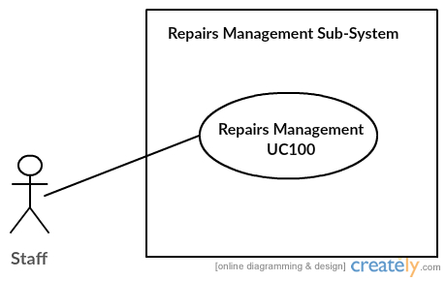

UC 110

Miss Uraiwan Puekphet 5730213031

**Use Case Diagram Level 1: Divice’s Management Sub-System (UC200)**

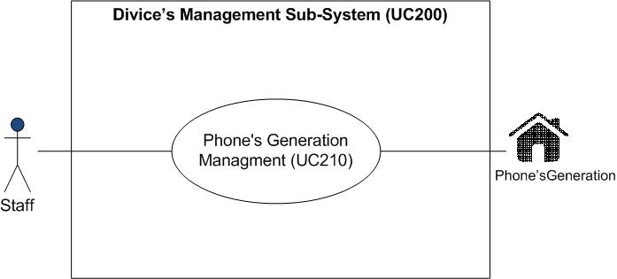

MissPuttinun Duangsamran 5730213038

**Use Case Diagram Level 1: Show Information Sub-System (UC300)**

**jasadaporn-usecaselv1**

UC 310

**Show Information Sub-System (UC300)**

Mr.Jasadaporn Sain-Un 5730213073

**Use Case Diagram Level 1: Personal’s Management Sub-System (UC400)**

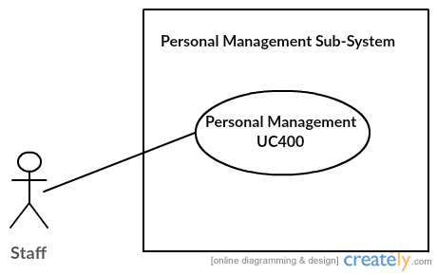

UC410

## Mr.Sitta Chumklaew 5730213074

**Use case Diagram LV1: Shop and Bill (UC500)**

**Bill**

Mr.Tanawat Meechai 5730213080

**Use Case Diagram Level 1: Report Sub-System (UC600)**

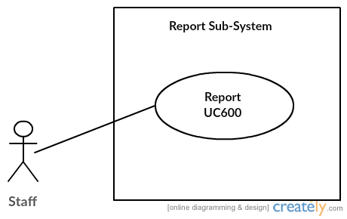

UC 610

Mr.Pasin Sommung 5730213096

## **Use Case Diagram Level 2: Repairs Management Sub-System (UC110)**

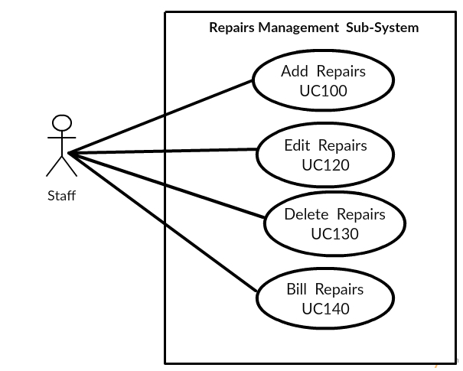

UC 114

UC 113

UC 112

UC 111

Miss Uraiwan Puekphet 5730213031

**Use Case Diagram Level 2 : Phone’s Generation Management (UC210)**

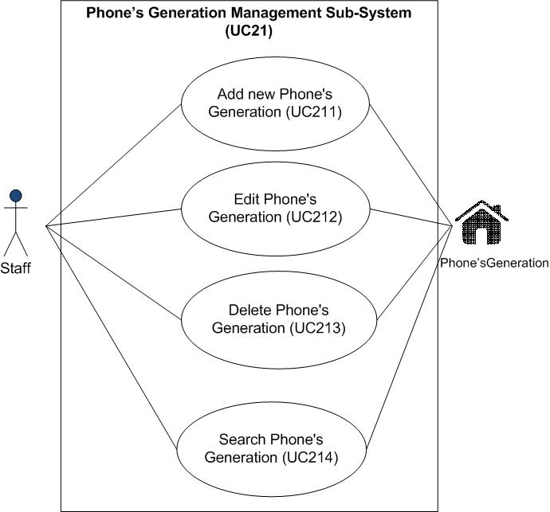

MissPuttinun Duangsamran 5730213038

**Use Case Diagram Level 2 : Show Information (UC310)**

**jasadaporn-usecaselv2**

UC315

UC314

UC313

UC312

UC311

Mr.Jasadaporn Sain-Un 5730213073

**Use Case Diagram Level 2: Personal’s Management Sub-System (UC410)**

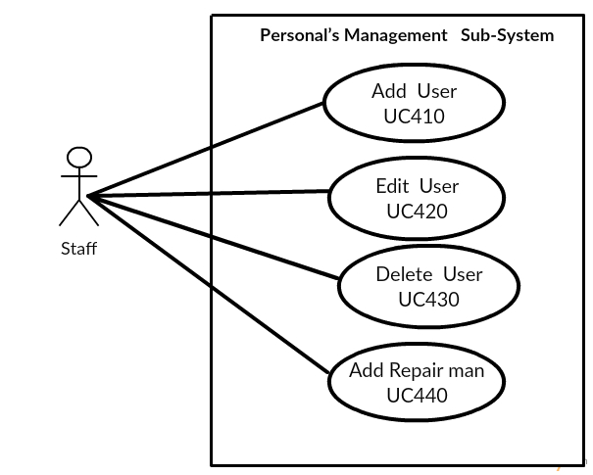

UC414

UC413

UC412

UC411

Mr.Sitta Chumklaew 5730213074

**Use case Diagram LV2 : Bill Management (UC510)**

**ucLv2Bill**

Mr.Tanawat Meechai 5730213080

**Use case LV2 : Shop Management (UC520)**

**ucLv2shop (1)**

Mr.Tanawat Meechai 5730213080

**Use Case Diagram Level 2 : Report Sub-System (UC610)**

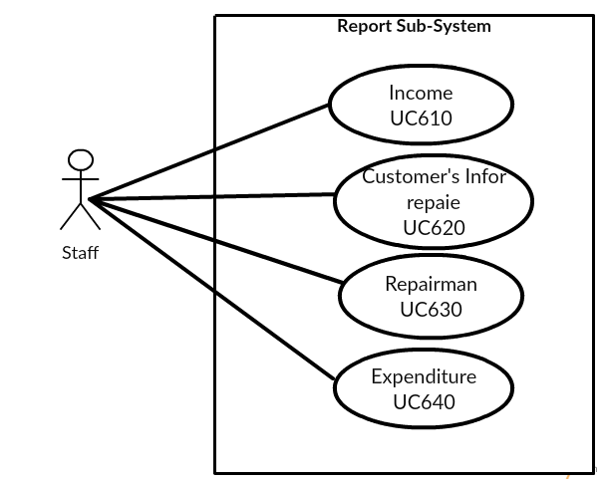

UC614

UC613

UC612

UC611

Mr.Pasin Sommung 5730213096

# 3.System Structure



# 4. Static Structure and Data Analysis

**4.1 Model-View-Controller (MVC) Model**

**MVC Add Repairs**

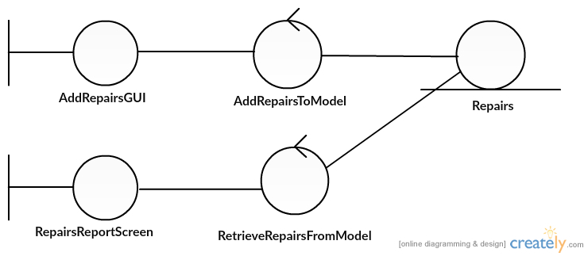

Miss Uraiwan Puekphet 5730213031

**MVC Edit Repairs**

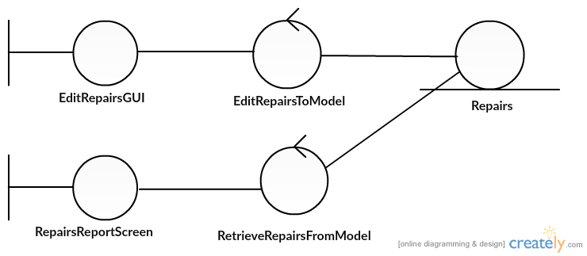

Miss Uraiwan Puekphet 5730213031

**MVC Delete Repairs**

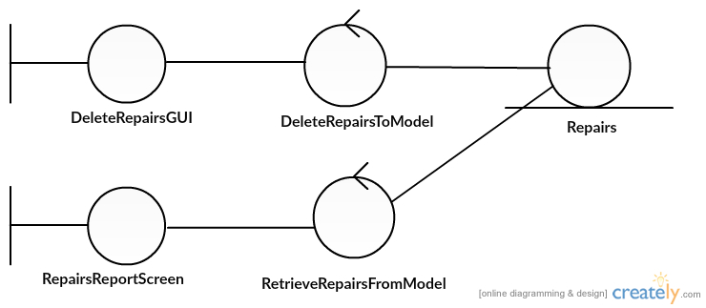

Miss Uraiwan Puekphet 5730213031

**MVC Print bill Repairs**

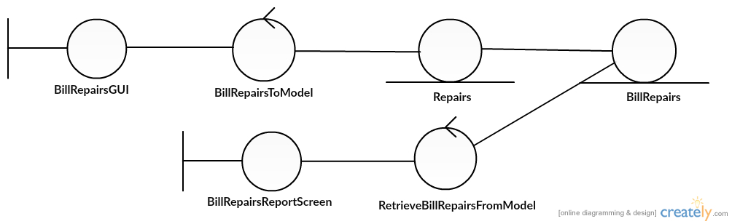

Miss Uraiwan Puekphet 5730213031

**MVC Add Phone’s Generation**

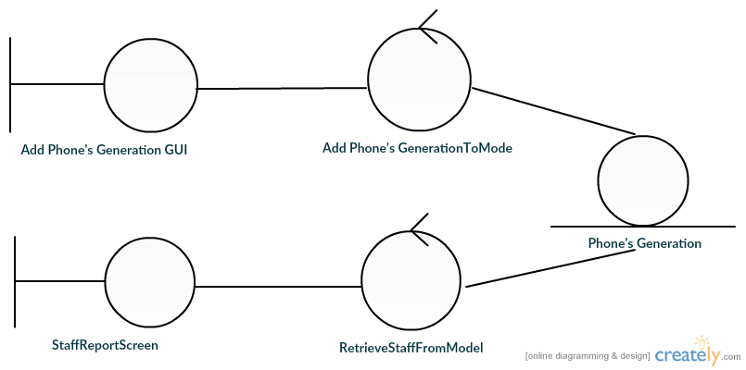

MissPuttinun Duangsamran 5730213038

**MVC Edit Phone’s Generation**

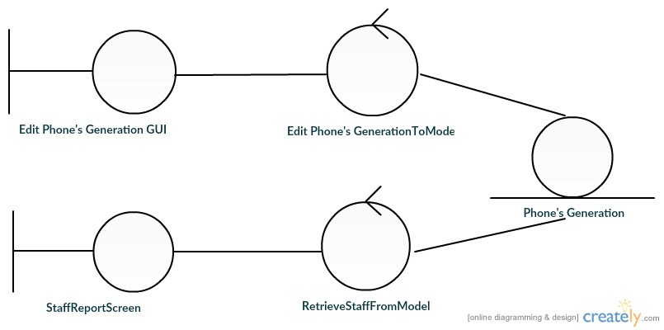

MissPuttinun Duangsamran 5730213038

**MVC Delete Phone’s Generation**

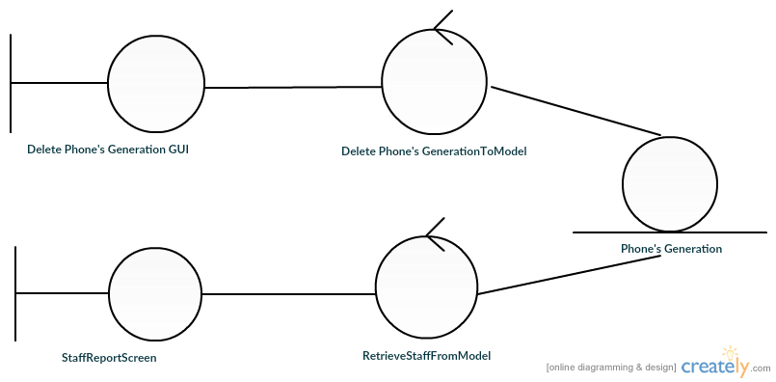

MissPuttinun Duangsamran 5730213038

**MVC Search Phone’s Generation**

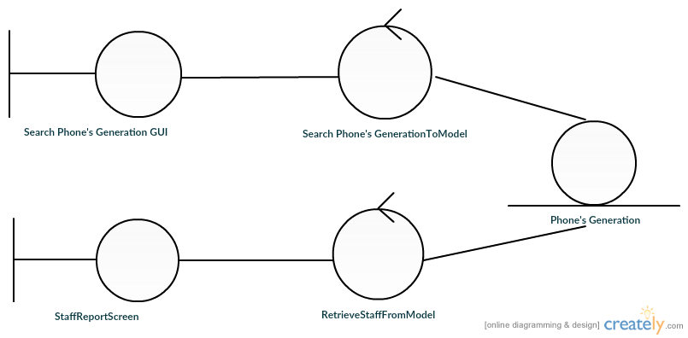

MissPuttinun Duangsamran 5730213038

**MVC Show customer take back**

**1**

Mr.Jasadaporn Sain-Un 5730213073

**MVC Show turn to customer**

**2**

Mr.Jasadaporn Sain-Un 5730213073

**MVC Show wait for repair**

**3**

Mr.Jasadaporn Sain-Un 5730213073

**MVC Show repair is done**

4

Mr.Jasadaporn Sain-Un 5730213073

**MVC Show take to repair center**

**C:\Users\DELL\AppData\Local\Microsoft\Windows\INetCache\Content.Word\Mvc take to repair.png**

Mr.Jasadaporn Sain-Un 5730213073

**MVC Add User**

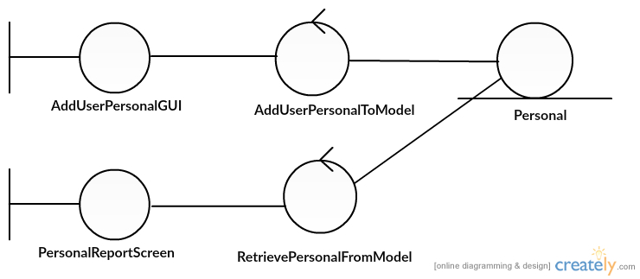

Mr.Sitta Chumklaew 5730213074

**MVC Edit User**

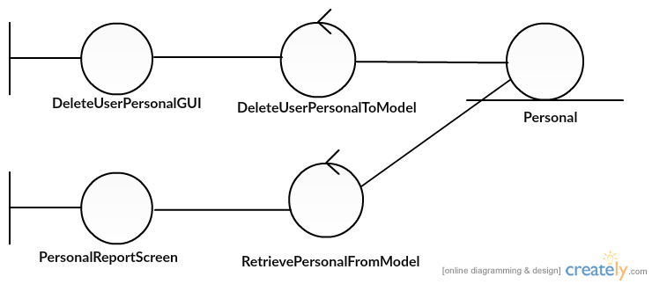

Mr.Sitta Chumklaew 5730213074

**MVC Delete User**

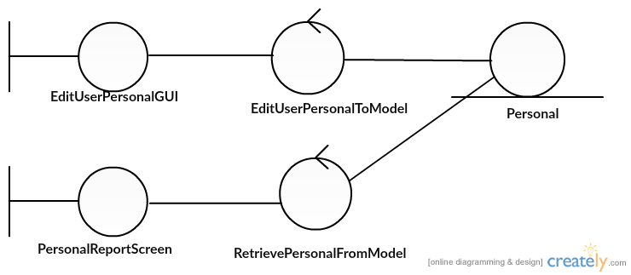

Mr.Sitta Chumklaew 5730213074

**MVC Add Repairman**

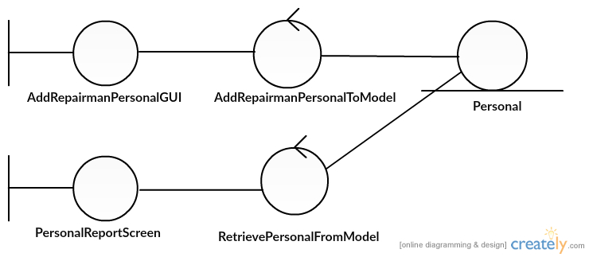

Mr.Sitta Chumklaew 5730213074

**Bill Management**



Mr.Tanawat Meechai 5730213080



Mr.Tanawat Meechai 5730213080



Mr.Tanawat Meechai 5730213080

**Shop Management**



Mr.Tanawat Meechai 5730213080



Mr.Tanawat Meechai 5730213080

**MVC Income**

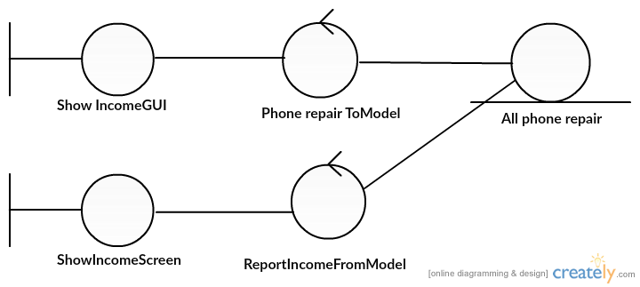

Mr.Pasin Sommung 5730213096

**MVC Customer’s info. As Repair**

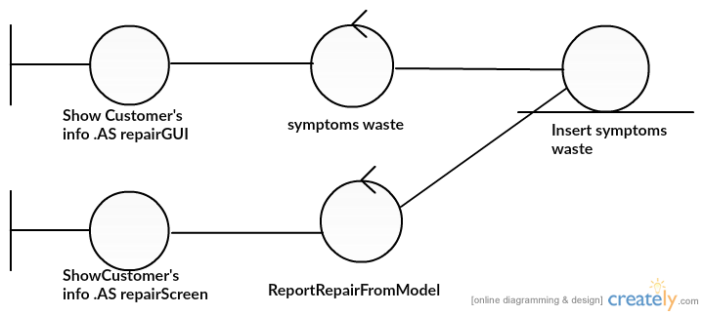

Mr.Pasin Sommung 5730213096

**MVC Repairman**

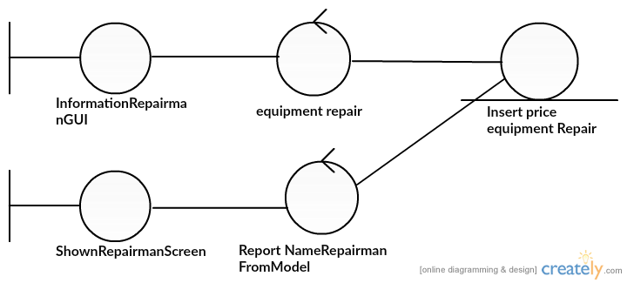

Mr.Pasin Sommung 5730213096

**MVC Expenditure**

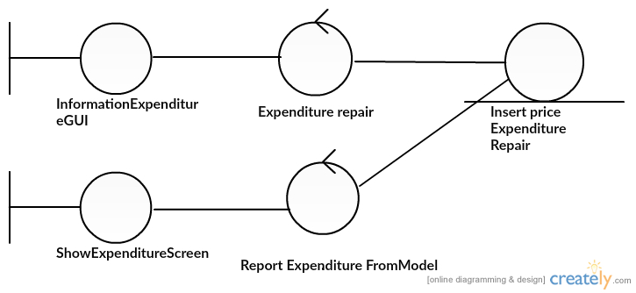

Mr.Pasin Sommung 5730213096

**4.2Class Diagram**



**5.System Behaviour Model**

**Sequence Diagram demonstrating operation “add, update, delete, bill repairs”**

* This diagram describes the system scenario of “UC111: Add Repairs”

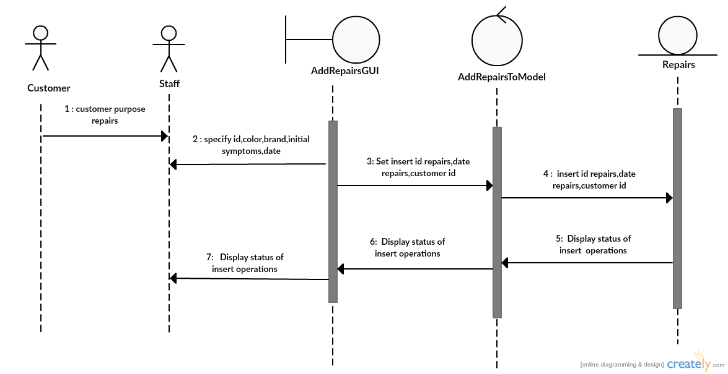

Miss Uraiwan Puekphet 5730213031

* 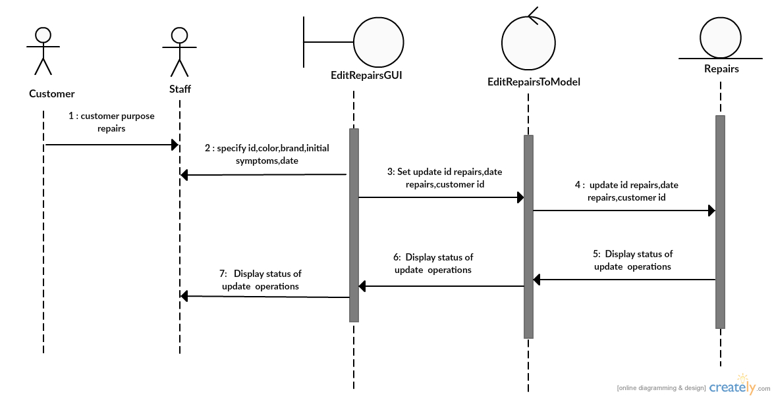This diagram describes the system scenario of “UC112: Edit Repairs”

Miss Uraiwan Puekphet 5730213031

* This diagram describes the system scenario of “UC113:Delete Repairs”

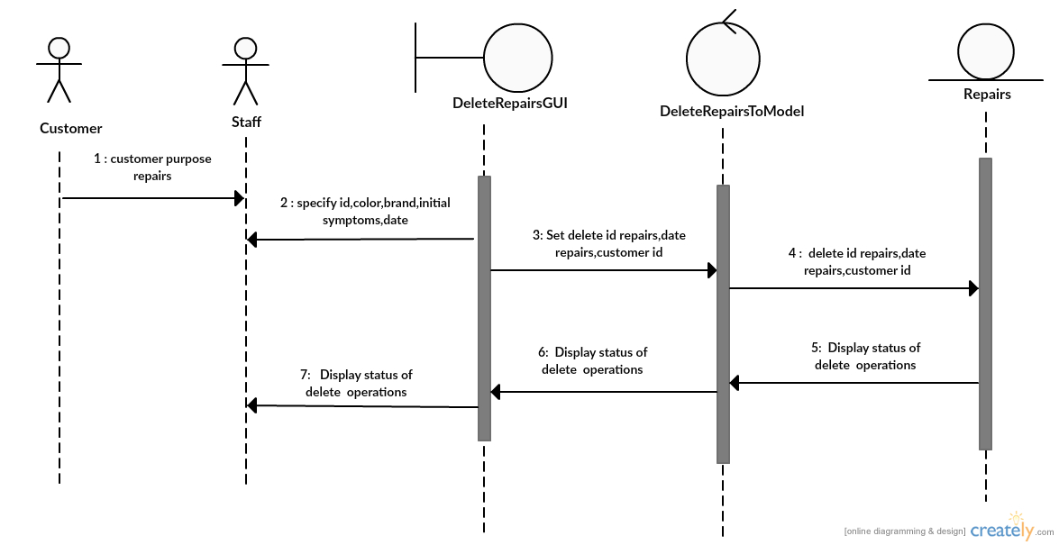

Miss Uraiwan Puekphet 5730213031

* This diagram describes the system scenario of “UC114:Bill Repairs”

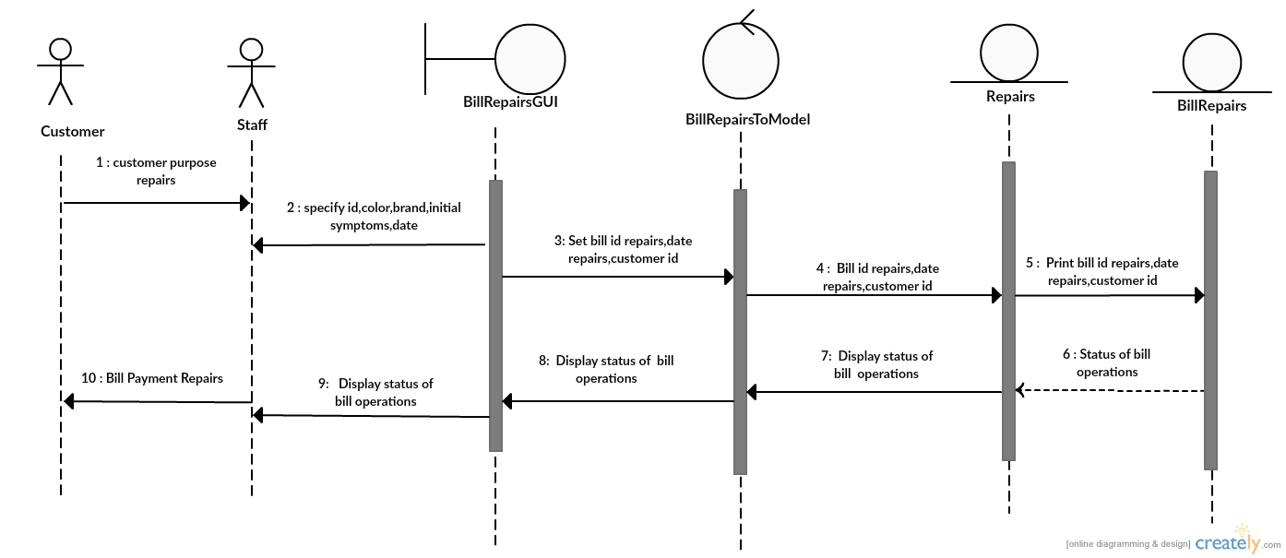

Miss Uraiwan Puekphet 5730213031

**Sequence Diagram demonstrating operation “add new Phone’s Generation”**

* This diagram describes the system scenario of **“UC211: Add new Phone’s Generation”**

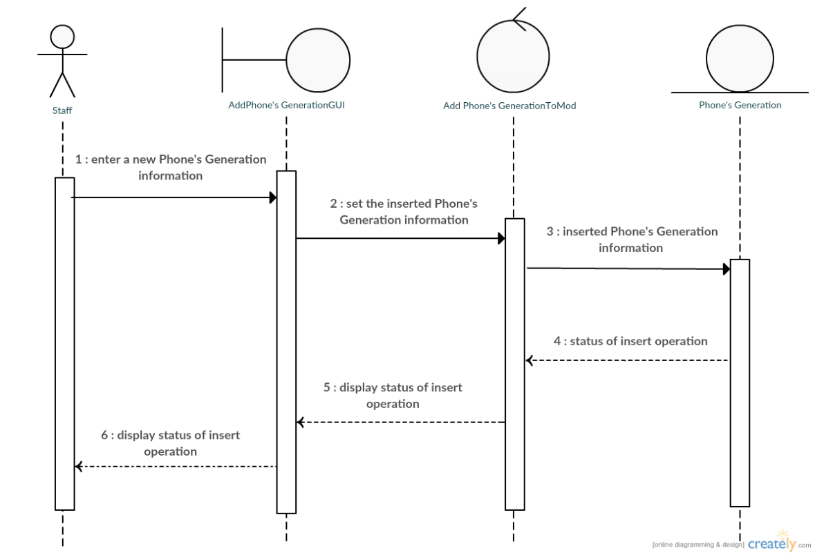

MissPuttinun Duangsamran 5730213038

**Sequence Diagram demonstrating operation “update Phone’s Generation”**

* This diagram describes the system scenario of **“UC212: Edit Phone’s Generation”**

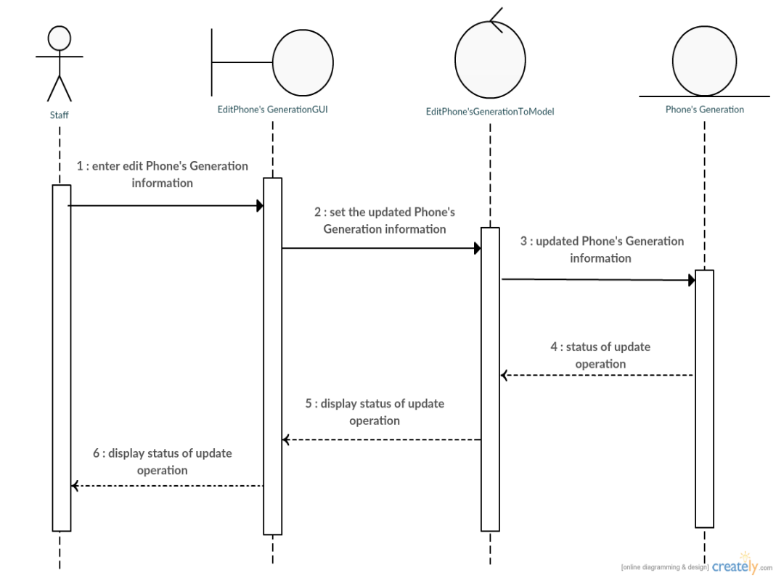

MissPuttinun Duangsamran 5730213038

**Sequence Diagram demonstrating operation “delete Phone’s Generation”**

* This diagram describes the system scenario of **“UC213: Delete Phone’s Generation”**

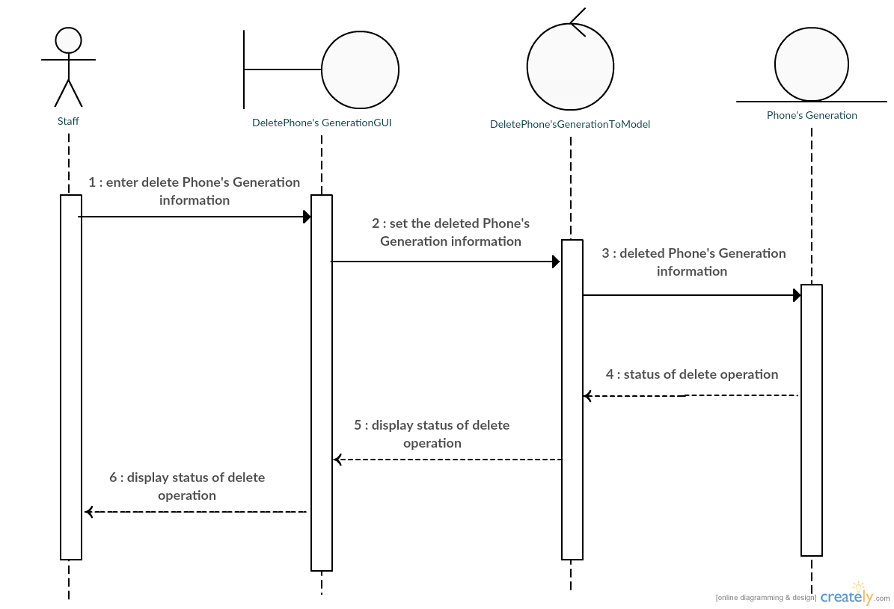

MissPuttinun Duangsamran 5730213038

**Sequence Diagram demonstrating operation “search Phone’s Generation”**

* This diagram describes the system scenario of **“UC214: Search Phone’s Generation”**

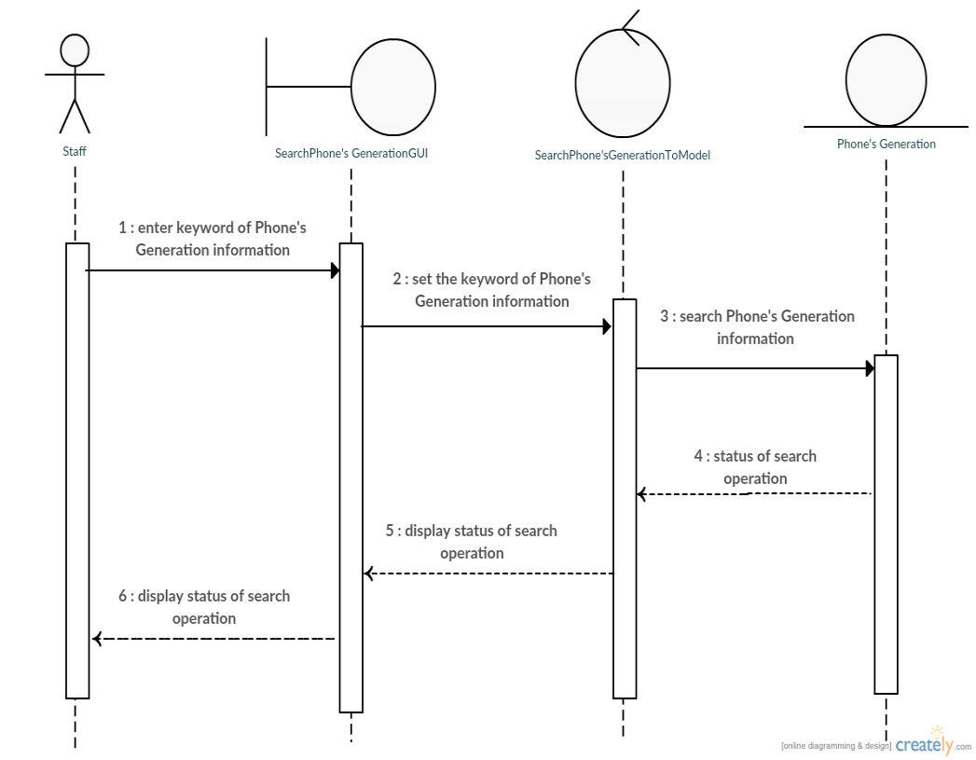

MissPuttinun Duangsamran 5730213038

**Sequence Diagram demonstrating operation “show customer take back”**

* This diagram describes the system scenario of **“UC311: show customer take back”**

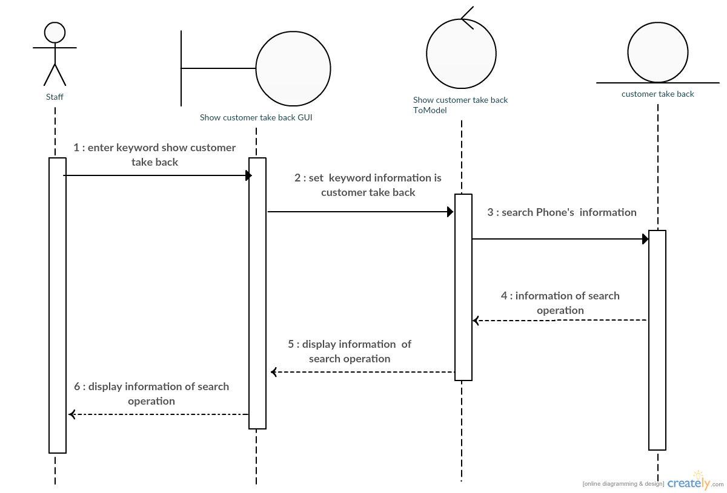

Mr.Jasadaporn Sain-Un 5730213073

**Sequence Diagram demonstrating operation “turn back to customer”**

* This diagram describes the system scenario of **“UC312: turn back to customer”**

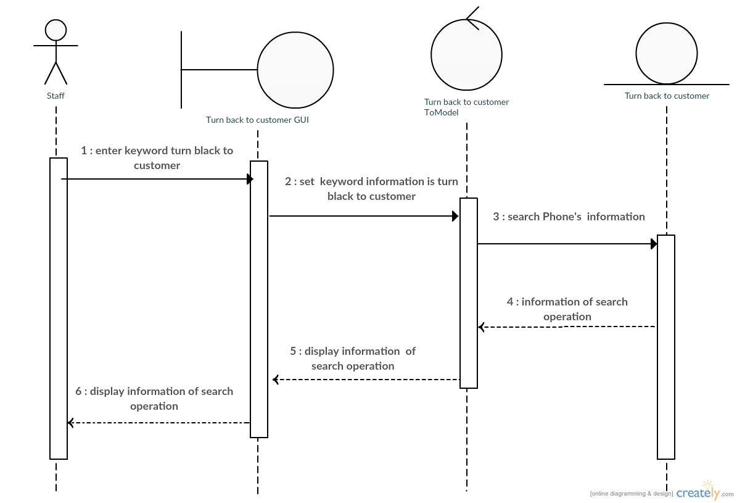

Mr.Jasadaporn Sain-Un 5730213073

**Sequence Diagram demonstrating operation “waiting for repair”**

* This diagram describes the system scenario of **“UC313: waiting for repair”**

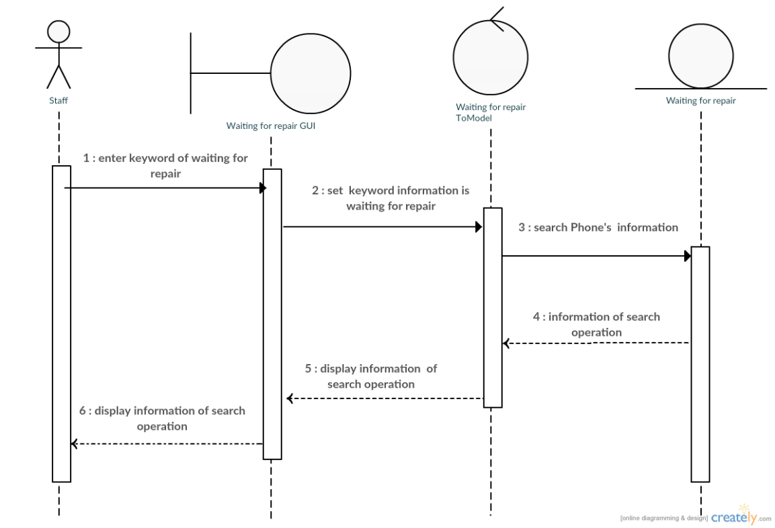

Mr.Jasadaporn Sain-Un 5730213073

**Sequence Diagram demonstrating operation “repair is done”**

* This diagram describes the system scenario of **“UC314: repair is done”**

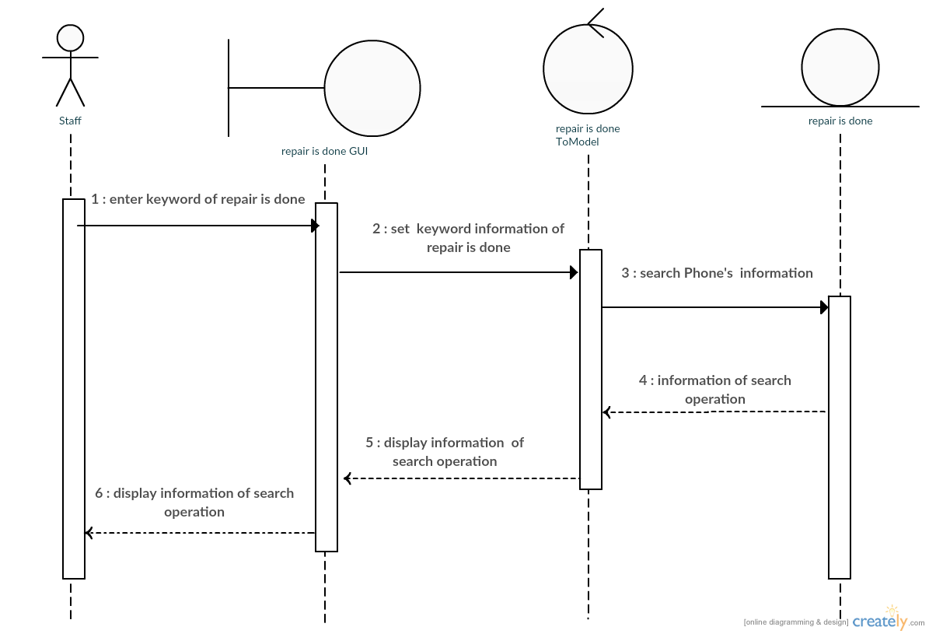

Mr.Jasadaporn Sain-Un 5730213073

**Sequence Diagram demonstrating operation “Take to repair canter”**

* This diagram describes the system scenario of **“UC315: Take to repair canter”**

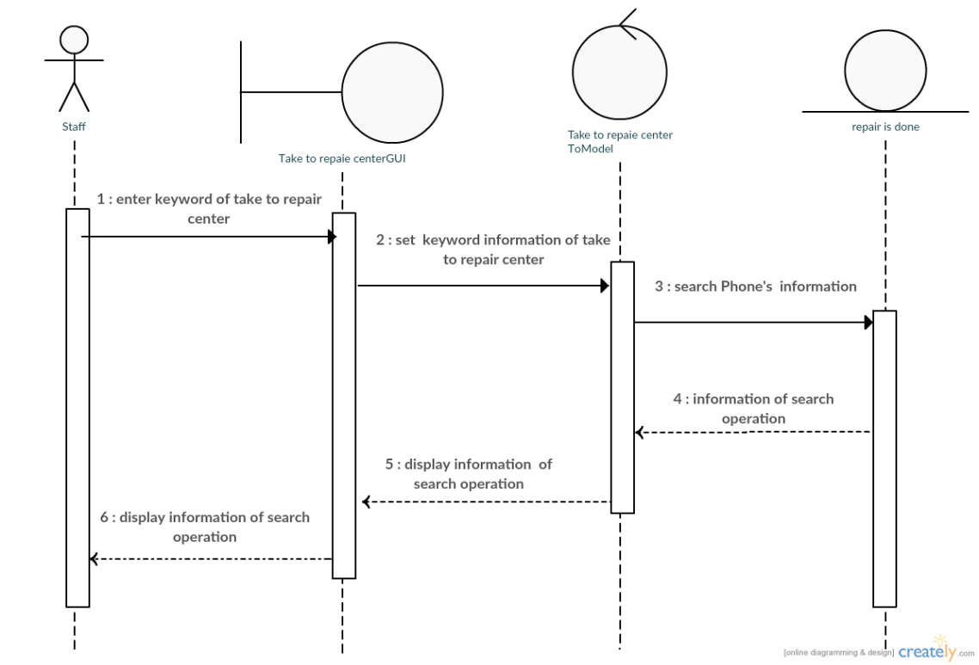

Mr.Jasadaporn Sain-Un 5730213073

**Sequence Diagram demonstrating operation “Add User, Edit User, Delete User,Add repairman”**

* 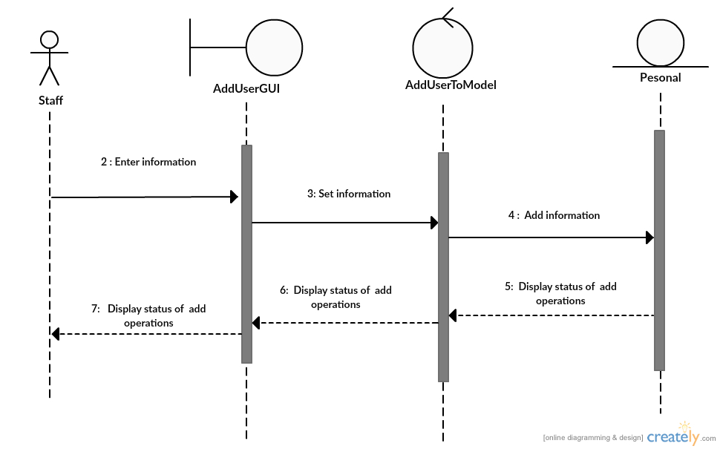This diagram describes the system scenario of “UC411: Add User”

Mr.Sitta Chumklaew 5730213074

* 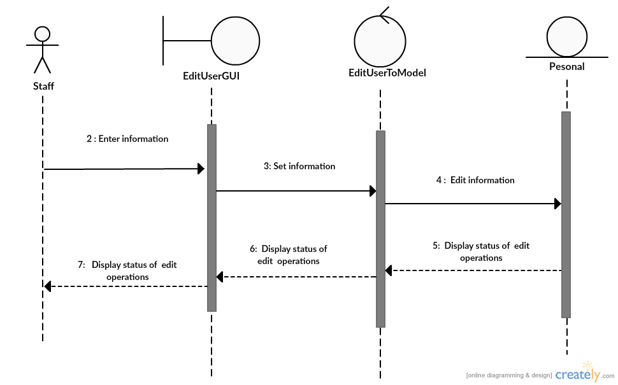This diagram describes the system scenario of “UC412: Edit User”

Mr.Sitta Chumklaew 5730213074

* This diagram describes the system scenario of “UC413:Delete User”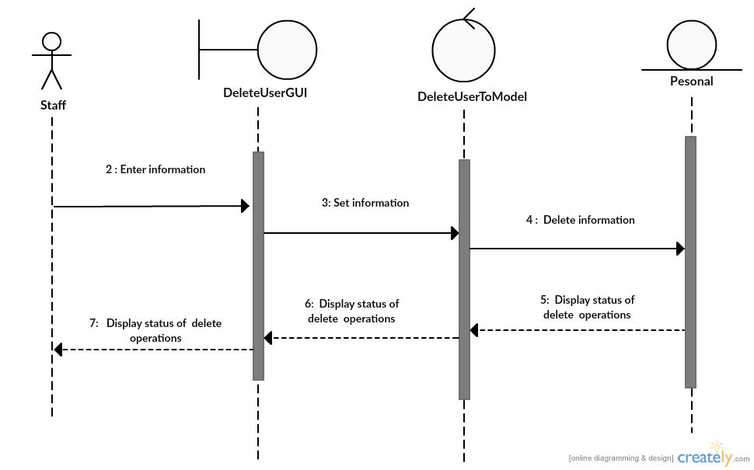

Mr.Sitta Chumklaew 5730213074

* 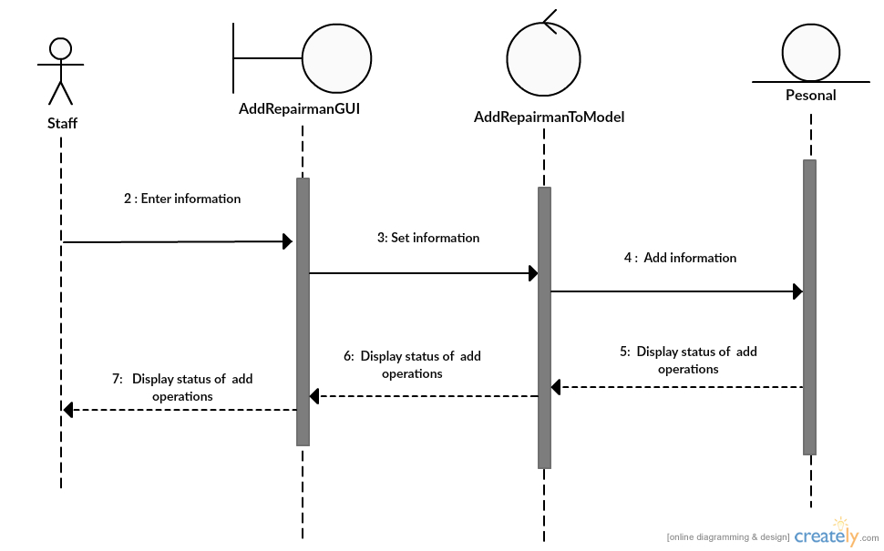This diagram describes the system scenario of “UC414:Bill Repairs”

Mr.Sitta Chumklaew 5730213074

**Sequence Diagram demonstrating operation “add Bill”**

* This diagram describes the system scenario of **“UC511: Add Bill”**



Mr.Tanawat Meechai 5730213080

**Sequence Diagram demonstrating operation “Update Bill”**

* This diagram describes the system scenario of **“UC512: Update Bill”**



Mr.Tanawat Meechai 5730213080

**Sequence Diagram demonstrating operation “Search Bill”**

* This diagram describes the system scenario of **“UC513: Search Bill”**



Mr.Tanawat Meechai 5730213080

**Sequence Diagram demonstrating operation “Add About Shop”**

* This diagram describes the system scenario of **“UC521: Add About Shop”**



Mr.Tanawat Meechai 5730213080

**Sequence Diagram demonstrating operation “Update About Shop”**

* This diagram describes the system scenario of **“UC522: Update About Shop”**



Mr.Tanawat Meechai 5730213080

**Sequence Diagram demonstrating operation “In come”**

* This diagram describes the system scenario of **“UC611: Income”**

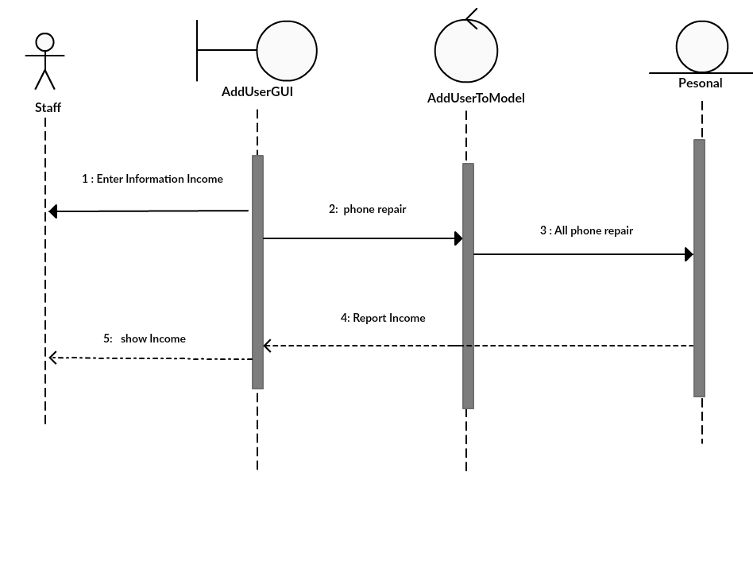

Mr.Pasin Sommung 5730213096

**Sequence Diagram demonstrating operation “Customer’s Info. As Repair”**

* This diagram describes the system scenario of **“UC612:Customer’s Info. As Repair ”**

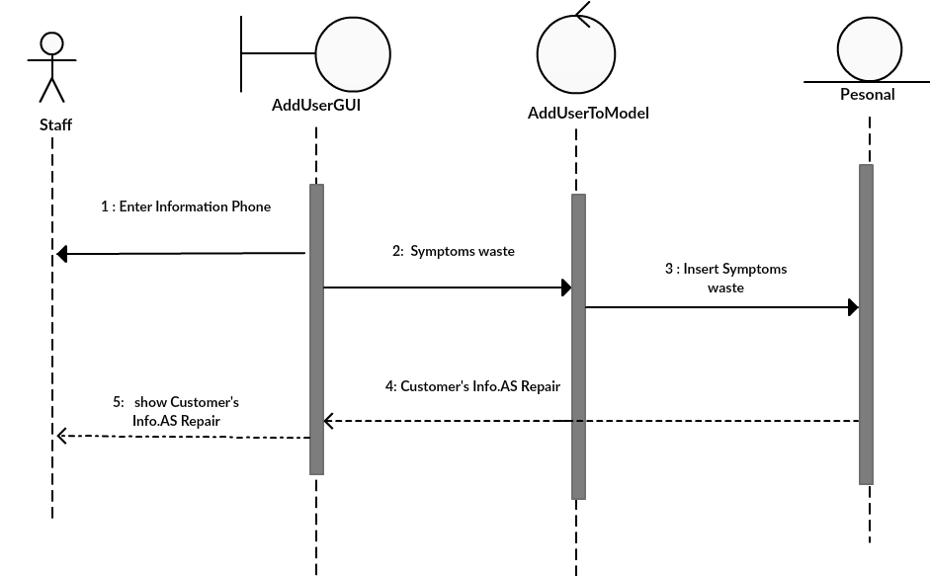

Mr.Pasin Sommung 5730213096

**Sequence Diagram demonstrating operation “Repairman”**

* This diagram describes the system scenario of **“UC613: Repairman”**

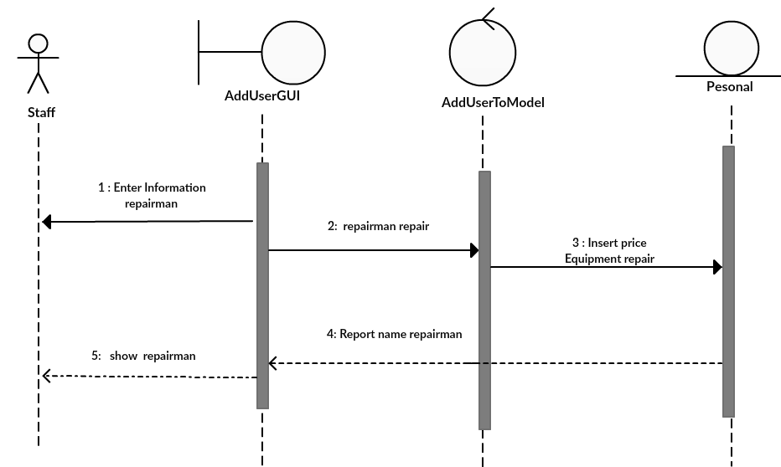

Mr.Pasin Sommung 5730213096

**Sequence Diagram demonstrating operation “expenditure”**

* This diagram describes the system scenario of **“UC614: expenditure”**

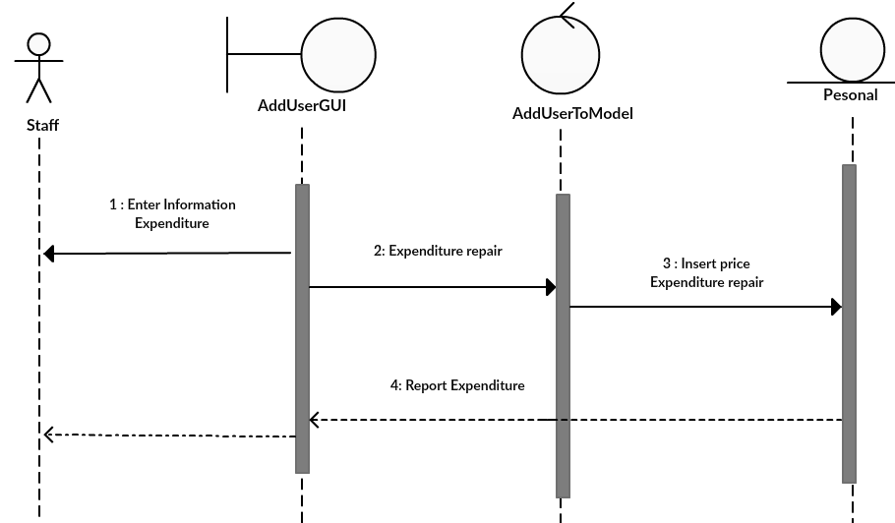

Mr.Pasin Sommung 5730213096